Cloud Computing Experiment – 5

Question:
Create a simple cloud software application for Library book reservation system for SIMATS library using any Cloud Service Provider to demonstrate SaaS.
Answer:
AIM: To design and deploy a Library Book Reservation System for SIMATS Library as a SaaS application using Zoho Creator.
PROCEDURE:
Log in to Zoho Creator and start a new app from scratch.
- Create a Book Details form to store book info and availability.
- Create a Member Details form to keep records of students and staff.
- Create a Book Reservation / Issue form and connect members with books using lookup fields.
- Add workflows to update book availability and set due dates.
- Deploy the app so library users can access it online (cloud-based).
- Your library software is ready

IMPLEMENTATION:

Library Book Reservation System.

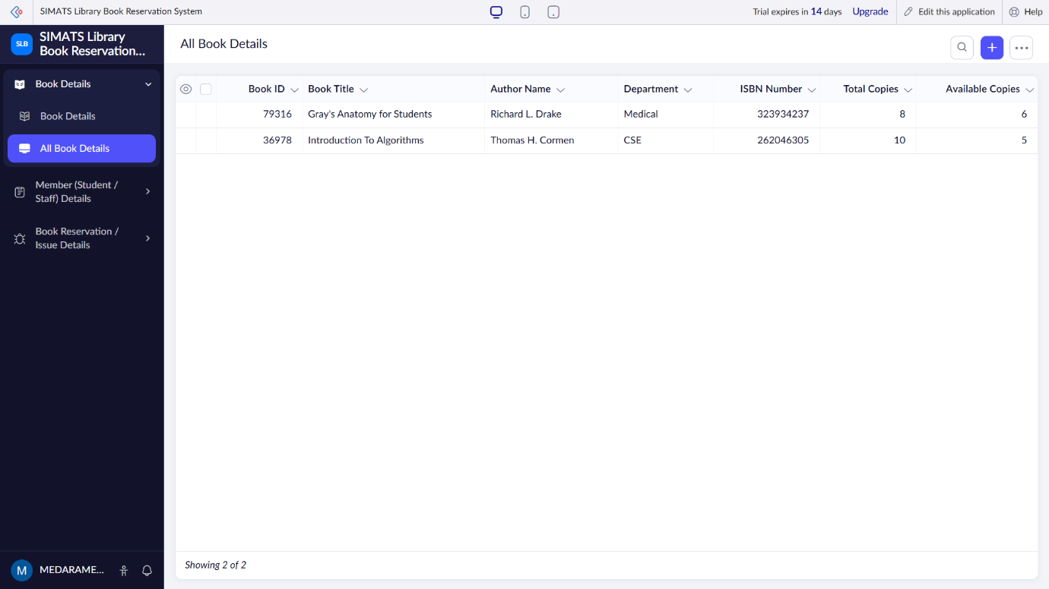

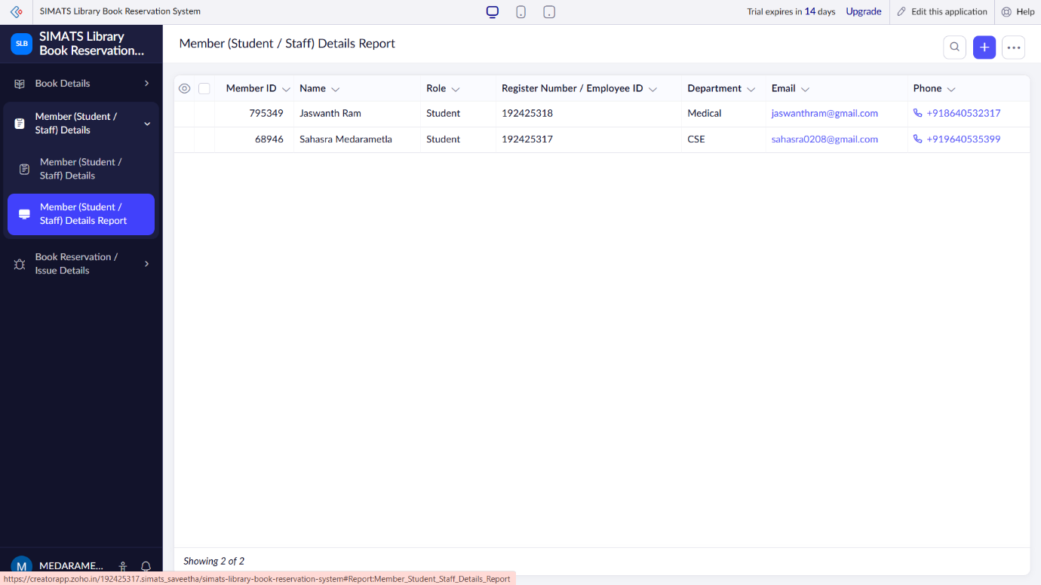
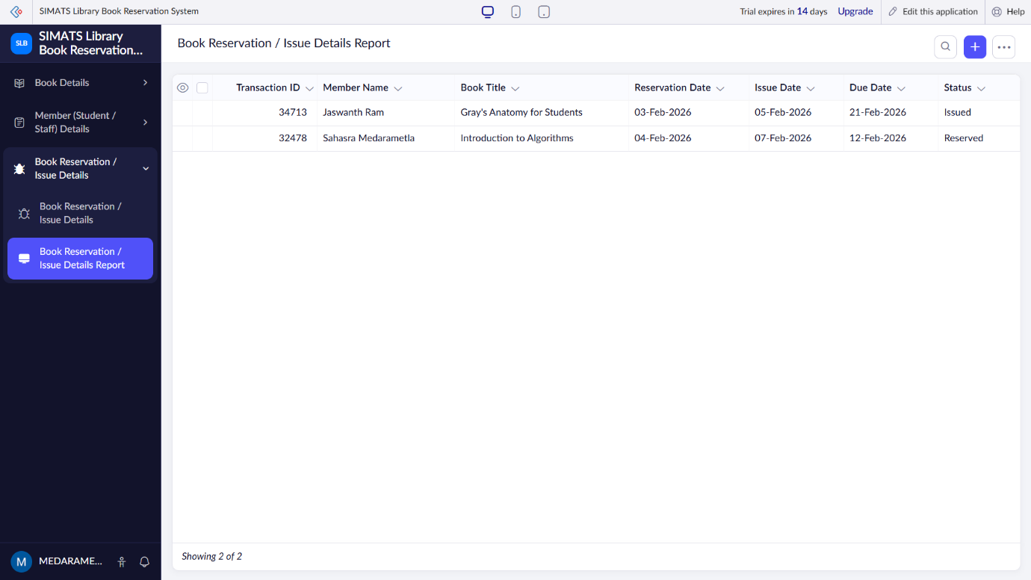

RESULT: A SIMATS Library Book Reservation System is successfully implemented as a SaaS application, enabling efficient online book reservation and management.

